Abstract Art
Abstract art is any art that uses form, line, and color to create a composition that does not aim to represent the world as it appears to the human eye. As a visual language developed by the European AVANT-GARDE in the early twentieth century, abstract art broke with the standards of realistic representation that had dominated the visual arts since the Renaissance. Unlike decorative art, which similarly rejects the world of appearances, abstract art goes beyond style and presents a philosophical challenge to the assumption that art aspires to imitate nature. Practitioners of abstract art did not belong to a single movement, but rather to many, including EXPRESSIONISM, CUBISM, SUPREMATISM, DE STIJL, and ABSTRACT EXPRESSIONISM.

Also see ABSTRACT EXPRESSIONISM, AMERICAN ABSTRACT ARTISTS, ART INFORMEL, ART NOUVEAU, AVANT-GARDE, BIOMORPHISM, CONSTRUCTIVISM (RUSSIAN), CUBISM, DE STIJL, EXPRESSIONISM, FAUVISM, FORMALISM, FUTURISM, ORPHISM, POST-IMPRESSIONISM, PRIMITIVISM, PURISM, and SUPREMATISM.

Conception and Origins
The word abstract derives from the Latin abstractus, meaning “drawn away from.” In art, the term approximates the degree to which an artist’s depiction of a form in the world withdraws from reality. THEO VAN DOESBURG, a Dutch artist and member of DE STIJL, illustrated this process of abstraction in a four-picture sequence he called An Object Aesthetically Transformed. In this sequence, he reduced the forms, lines, and colors of a cow to create in the final picture a purely abstract composition without any discernable reference to the realistic representation of the cow in the first picture. Within the spectrum of abstract art, however, Charles Harrison offers the distinction between weak and strong abstraction, between an abstract art that has a tenuous connection to visible reality and abstract art that is essentially non-objective. Non-objective, non-figurative, and non-representational art are all types of abstract art and expressions of “pure” abstraction.

Abstract art is sometimes said to be devoid of subject matter. If the abstract artwork does not depict a scene or story that is recognizable, then it lacks subject matter. But if it retains a weak connection to visible reality by suggesting a still life, landscape, or portrait, for example, it could yet have a subject. In both cases, however, the artwork’s formal properties are primary sources of its content (as opposed to its subject matter). Content is the meaning generated by the artwork’s formal properties as such. This distinction gave rise to an approach to the study of abstract art known as FORMALISM, which was popularized by British art critics Clive Bell and Roger Fry and the American art critic Clement Greenberg.

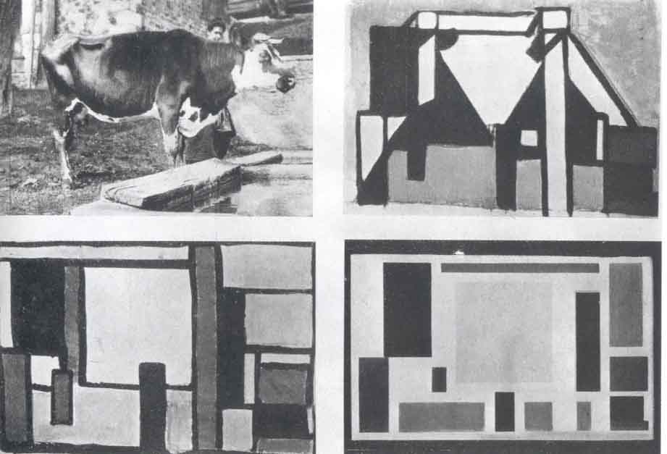Theo van Doesburg, An Object Aesthetically Transformed, ca.1917

Abstract art principally emerged in the late nineteenth century out of POST-IMPRESSIONISM. Artists such as PAUL CÉZANNE and GEORGES SEURAT explored the optical dimensions of form and color while PAUL GAUGUIN and VINCENT VAN GOGH emphasized the symbolic and emotional qualities of color and line. At the same time, French artist Maurice Denis famously observed: “Remember that a picture – before being a war horse or a nude woman or an anecdote – is essentially a flat surface covered with colors assembled in a certain order.” Other movements of the period, such as ART NOUVEAU, stressed the abstract qualities of plant forms that would later develop into what Alfred H. Barr, Jr. dubbed BIOMORPHISM. PRIMITIVISM also hastened the development of abstract art. Many avant-garde artists assimilated the abstract formal languages of non-Western art in their radical departures from the mimetic tradition of the West.

VASILY KANDINSKY is widely acknowledged as having been the first artist to experiment with “pure” abstraction. An Expressionist artist and member of the German AVANT-GARDE group DER BLAUE REITER, KANDINSKY advocated for the spiritual content of abstract art in his treatise Über das Geistige in der Kunst (Concerning the Spiritual in Art) published in 1912. Personal experience was key to his transformation; several years prior, Kandinsky spied one of his paintings from a distance and realized: “The painting lacked all subject, depicted no identifiable object and was entirely composed of bright color-patches. Finally I approached closer and, only then, recognized it for what it really was – my own painting, standing on its side on the easel… One thing became clear to me – that objectiveness, the depiction of objects, needed no place in my paintings, and was indeed harmful to them.”

Vasily Kandinsky, Picture with a Circle, 1911 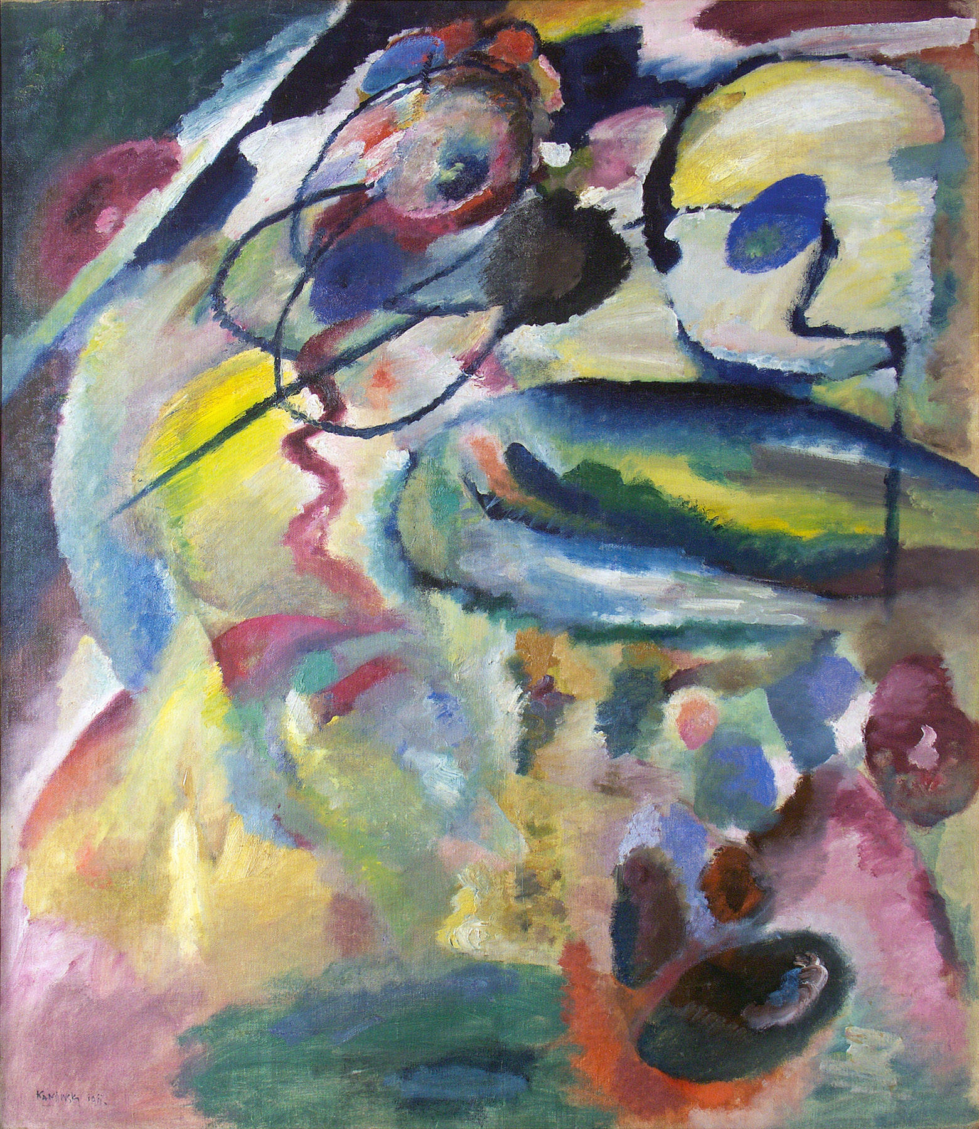

Abstract Art in Europe
Among the first AVANT-GARDE movements to claim abstraction as its formal language was FAUVISM. HENRI MATISSE used organic forms, saturated colors, and gestural brushwork for their purely expressive qualities. In “Notes d’un peintre” (“Notes of a Painter”) from 1908, he pronounced: “the entire arrangement of my picture is expressive.” Cubist painters and sculptors also embraced abstraction in their almost philosophical rejection of traditional pictorial techniques (such as modeling and perspective) in favor of flat, interconnected planes and forms. At the same time, the German artists of DIE BRÜCKE abstracted studio and urban scenes as a way to express the psychic malaise they believe had infected modern society. By contrast, the Italian Futurists exploited abstraction to celebrate the abstract forms of the industrial city.

Other major AVANT-GARDE movements associated with abstract art were ORPHISM, PURISM, DE STIJL, SUPREMATISM and CONSTRUCTIVISM. ORPHISM and PURISM flourished in France before and after World War I, respectively, and both movements grew out of CUBISM. ORPHISM emphasized the lyrical and decorative qualities of color whereas PURISM promoted a rational aesthetic inspired by modern machinery. DE STIJL and SUPREMATISM were each born during the war in the Netherlands and Russia, respectively. Members of both movements utilized the geometric language of abstract art, reducing their pictures to mostly primary colors, rectilinear shapes, and straight lines. The Dutch artist PIET MONDRIAN advocated a utopian ideal of social harmony “express[ed] in the abstraction of form and color, that is to say, in the straight line and the clearly defined primary color.” Meanwhile, KAZIMIR MALEVICH promoted pure form in his Suprematist paintings such as Black Square from 1914-15, declaring: “The artist can be a creator only when the forms of his pictures have nothing in common with nature.” CONSTRUCTIVISM, which emerged in the wake of the Russian Revolution, abandoned the autonomy of SUPREMATISM for an art that was actively engaged in the construction of a Communist society. For the CONSTRUCTIVISTS, abstract form made both a visual and political statement in its rejection of realism, which was associated with bourgeois taste and values.

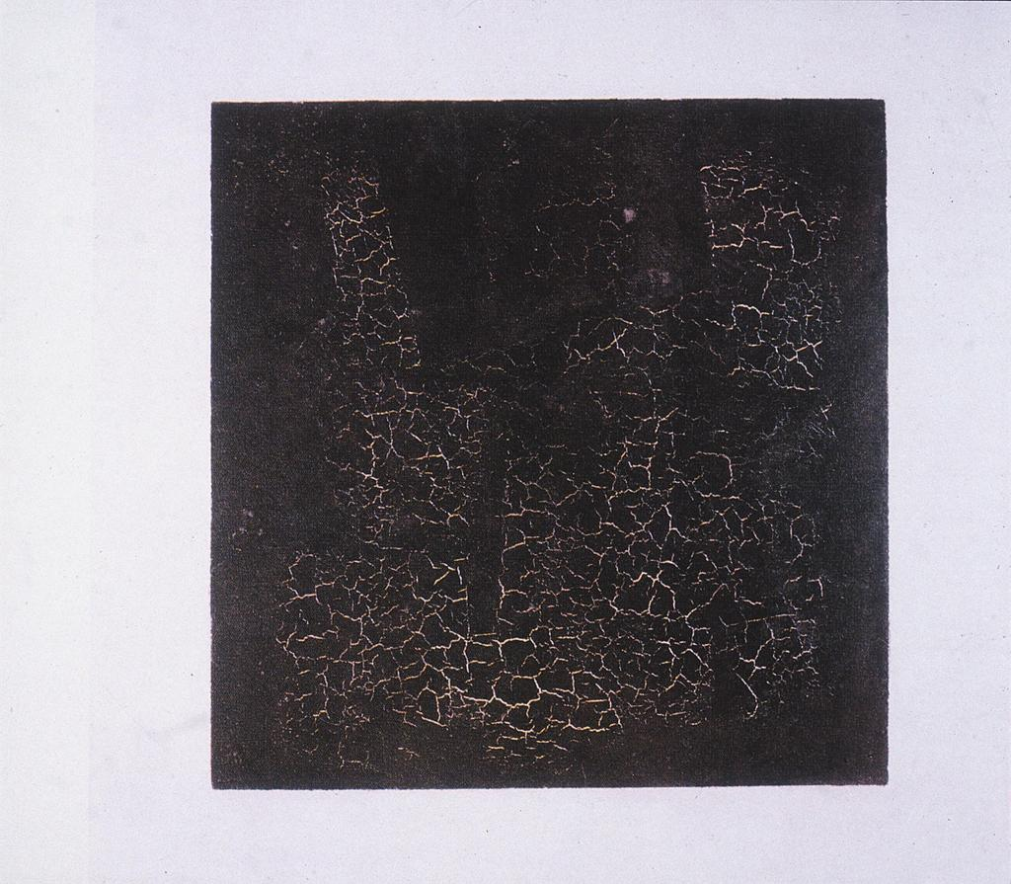 Kazimir Malevich, Black Square, 1914-15

Abstract Art in America
Although the progenitors of abstract art in America were European, AMERICAN ABSTRACT ARTISTS developed unique visual languages. Revisionist histories of modernism place the American artist ARTHUR DOVE alongside VASILY KANDINSKY as a pioneer of pure abstraction. DOVE’s organic, non-objective compositions of around 1911, such as Nature Symbolized, reveal the influence of the European AVANT-GARDE artists, whose work he had seen while visiting Paris in 1907. Yet the persistence of spatial depth through distinct, overlapping, and non-objective forms sets his work apart from his European contemporaries. In 1909, DOVE met ALFRED STIEGLITZ, the American art dealer who was instrumental in introducing American artists and audiences to European modernism and abstract art. STIEGLITZ exhibited DOVE’s work in his 291 Gallery in New York City alongside the work of other AMERICAN ABSTRACT ARTISTS such as Marsden Hartley and, later, GEORGIA O’KEEFFE.

Arthur Dove, Nature Symbolized, 1911 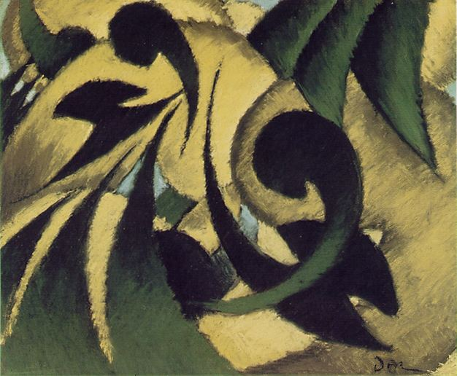

ABSTRACT EXPRESSIONISM was a distinct movement in the history American art that was characterized by modes of abstract art ranging from Willem de Kooning’s figurative abstraction to Mark Rothko’s non-objective Color Field Painting. This more popular phase of abstract art in America began in the years leading up to World War II when AVANT-GARDE American artists encountered the work of many modernist European painters fleeing fascism in Europe. Major exhibitions at the Museum of Modern Art in New York, including Cubism and Abstract Art from 1936, also had a considerable impact on the work of young American artists such as Jackson Pollock, whose drip technique and all-over compositions attracted the attention of the Clement Greenberg. Greenberg became one of the chief apologists for ABSTRACT EXPRESSIONISM, which coincided with a period of American cultural dominance following World War II. In 1965, Greenberg insisted: “It is not in principle that Modernist painting in its latest phase has abandoned the representation of recognizable objects. What it has abandoned in principle is the representation of the kinds of space that recognizable, three-dimensional objects can inhabit.” Meanwhile, postwar European artists affiliated with ART INFORMEL developed gestural abstract styles similar in appearance to, but distinct in message from ABSTRACT EXPRESSIONISM.

Key Reference Works:
Barr, Alfred H. Cubism and Abstract Art (1936)
Bell, Clive. Art (1914)
Fer, Briony. On Abstract Art (1997)
Greenberg, Clement. “Modernist Painting” (1965)
Harrison, Charles, et. al. Primitivism, Cubism, Abstraction (1993)
Kandinsky, Vasily. Über das Geistige in der Kunst (1912)
Malevich, Kazimir. “From Cubism and Futurism to Suprematism” (1916)
Matisse, Henri. “Notes d’un peintre” (1908)
Mondrian, Piet. “Natural Reality and Abstract Art” (1919)

